### IRevolution: A Data-Driven Exploration Of Apple's IPhone Impact In India

(TEAM NM ID: NM2023TNID15158)

# Team Members

# LOGESWARI R

# SARANYA S

# SINDHUPRIYA S

# PADMAVATHI G

# INTRODUCTION

* 1. **Overview**
  2. The world has changed as a consequence of the increasing use of smartphones, which have improved communication, connected people, and revolutionized many different businesses. With its main product, the iPhone, capturing markets around the world, Apple Inc. has emerged as a prominent player among the top smartphone makers.
  3. **Purpose**
  4. In order to shed light on important factors like market penetration, customer preferences, economic ramifications, and societal changes, this research report will perform a data-driven investigation of the impact of the iPhone in India.

1. **ProblemDefinition&DesignThinking**

**Empathy map**

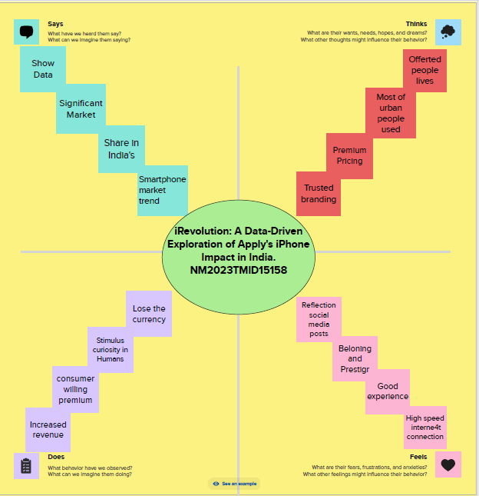

* 1. **Ideation&BrainstormingMap**
  2. 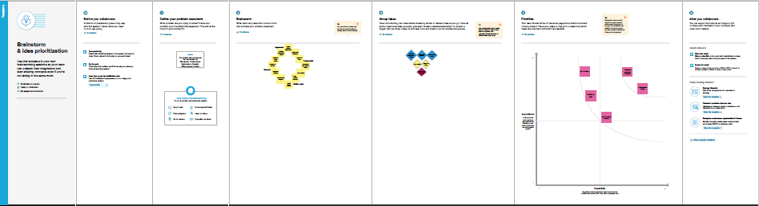

# RESULT

# Annotation 2023-10-13 002831.png

# Annotation 2023-10-13 001805.png

# Annotation 2023-10-13 003044.png

# ADVANTAGES&DISADVANTAGES

* User-Friendly Interface: The iPhone has an intuitive user interface that makes it easy to navigate. ...
* High-Quality Display: The iPhone's Retina display is one of the best in the market. ...
* Advanced Camera: iPhone devices have some of the best cameras in the market.

# APPLICATIONS

* This study will offer invaluable insights into **the** transformative **impact** of **the iPhone** on **India's** technological landscape and **the** lives of its consumers by ...

# CONCLUSION

* In summary, it is apparent that the iPhone was, and still, a remarkable invention of technological advancement. The iPhone provided a new way of mobile phone communication and usability. Its revolutionary technology has led to the variety of smartphones that are in use today.

# FUTURESCOPE

* The iPhone flipped all of that and introduced a revolutionary new design that was sleek and elegant, with a large touchscreen that took up most of the device's front. The user interface was intuitive, easy to use, and offered a wide range of features that were not available on any other smartphone at the time.

.